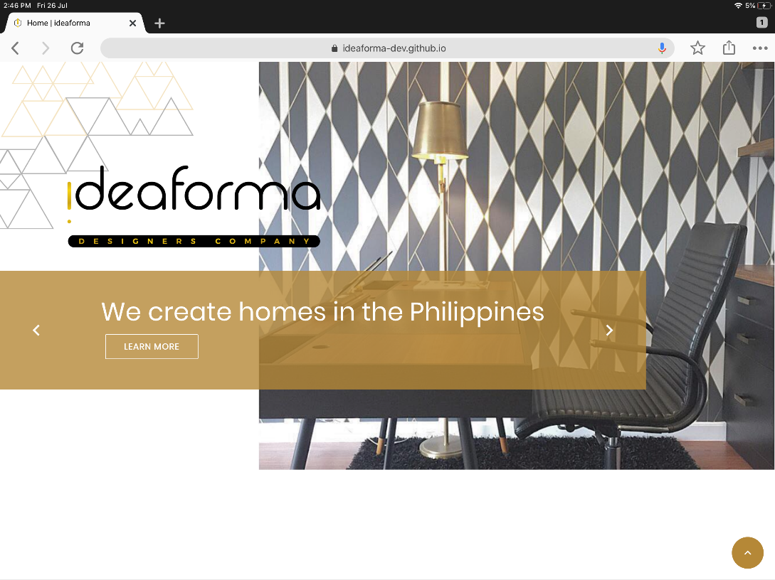

* Change copy to “Creating homes in the Philippines”
* Please use any of the following colors for the rectangle:
  + 246 211 19 / #F60313
  + 214 175 22 / #D6AF16
  + 222 184 23 / #DEB817
* Remove arrows in the rectangle, and “Learn More” button
* Can we make the rectangle smaller/thinner?

Please put this image as an alternate image for the homepage:

* Kindly re-layout to fit the space equal to the image in the homepage
* We want to feature three key numbers and then the rest of the numbers can be in smaller fonts/shapes
* Final list of numbers to be included in layout:
  + 11 Years in Business
  + 94 Houses
  + 134 Condominium Units
  + 14,004 SQMs Turned Over
  + 25 Office Spaces
  + 26 Retail Stores
  + 13 Restaurants
  + 2 Schools
  + [NEW] 313 Skilled Workers Employed
  + [NEW] 414,000 Color Palettes Chosen
* Featured numbers (bigger in size compared to others)
  + Years in Business
  + Houses
  + Condominium Units
* Numbers with photo BG
  + Skilled Workers Employed
  + Unique Cities (! Office Spaces)
  + Houses
* BG colors for the rest of the numbers should be random either gold, black or white

* This should come after the home page
* Can we revise the layout for this to accommodate 5 people?
* Let’s put placeholders first for the two other photos since I don’t have these yet
* List of Names and Job Titles to be included:
  + IDr. Malen Gomez – Garcia (Creative Director)
  + Nina Gomez – Camacho (General Manager)
  + Lisa Gomez (Marketing Head)
  + Rico Gomez (Asst. General Manager)
  + Erica Gomez (Marketing Associate)
* All descriptions for the Core Team Members to follow
* Descriptions:

1. IDr. Malen Gomez – Garcia

With over fifteen years of invaluable experience in the interior design industry & a sincere passion to understand each client’s behavior, needs & wants, Malen has designed hundreds of projects that her clients have called home. Her natural eye & style coupled with the right balance of form & function has molded the distinct character of an IdeaForma home.

1. Nina Gomez – Camacho

Nina, with her love for learning proven by achieving two master’s degrees, one in Business Management, and another in Entrepreneurship, plus significant brand & marketing experience in other industries, has grown the business from a one-man team to a fully functional interior design & project management firm. With Nina’s crystal clear focus on IdeaForma’s mission & vision, that is to be the preferred Home Management Company, there’s no stopping this team of siblings that she leads.

1. Lisa Gomez

With customer experience in this highly competitive service industry as her main priority, Lisa has recently introduced significant & personal touches in the whole IdeaForma experience. This marketing expert’s decade-long experience with one of the country’s most successful high-end developers, Rockwell Land Inc., has infused her with the greatest attention to detail, knowing that it’s the small things that truly matter.

1. Rico Gomez

Having handled multiple projects of different styles, paces & clients all through out his five years in the firm, Rico has perfected the smoothest implementation of the unique IdeaForma design process & over-all management. With almost a hundred projects under his sleeve, his project management, finance & administrative skills are truly quite remarkable.

1. Erica Gomez

With her fair share of outside experience in the client-servicing industry, particularly as a senior account manager of Nuworks Interactive Labs Inc., a young & vibrant advertising agency, Erica is now this design firm’s key to moving the IdeaForma service experience closer to perfection. Each project is unique and handled in the most personal manner but she ensures that every client recognizes those service trademarks of notable excellence & selfless service.

* Can you also propose a layout for the page to feature the other team members? This should be the landing page when “Meet The Team” is clicked
* List of Names:
  + **Debbie Ramos** (Operations Supervisor)
  + Mike Umbao (Administrative Staff)
  + **Rachel Tanada** (Sr. Design Associate)
  + Angelica Jaurigue (Jr. Interior Designer)
  + Reneca Abuso (Jr. Interior Designer)
  + Ally Asprec (Technical Designer)
* The names in BOLD should be bigger since they are the team leads

* Change page title to “Our Services”
* Change “Design & Development” to “Interior Design”
  + Description: Aesthetic and function are put together in *detailed drawings* with corresponding *material specifications*. These elements are carefully developed to complete the interior design blue print of the project.
* Please update description for “Project Management” to:
  + A meticulous process that monitors *budget* and *timeline* is implemented for cost-efficient and timely turnovers.
* Please note the words that need to be italicized and make sure the descriptions are justified instead of centered
* Can we request for alternative options for the icons to be used for “Interior Design” and “Project Management”?
* Change “Property Management” to “Home Management”
  + I will be providing a separate icon for Home Management – please see attached photo with the email

* Please update the headers per step to:
  + Absorb
  + Envision
  + Collaborate
  + Aim
  + Build
  + Live

ABSORB

We’ll start by listening to your story — learning about your lifestyle, your design concerns, the most precious of your possessions and the most important people in your life who will live in your home. We believe that the information that we gather from your current space is as important as learning about your dreams for the new one.

ENVISION

We’ll invite you IdeaForma’s creative playground where we’ll play with colors and toss around ideas until a design vision is created. This part of the process gives you a sneak peek of the end in mind. It’s a presentation of the big picture yet full of all those little details, all about your future home.

COLLABORATE

We’re all about working hand in hand with our clients in coming up with collaborative ideas and finding design solutions together —  from big decisions in furniture space planning to the littlest of details like organizing your closet shelves & drawers. Its putting together your needs & wants with our ideas & expertise in the most collaborative experience.

AIM

Considering both budget and timeline, we set clear cut goals. We pride ourselves with the most efficient monitoring and project management experience in interior design & construction making the experience as delightful as possible.

BUILD

Turning the vision to reality, we start building the space. As the one of the most critical phases in the process, we will keep you updated on all the accomplishments and promise the most creative solutions in times that bridging the vision and reality may become a challenge.

LIVE

We deliver as close to the design perspectives. We clean each nook & cranny. We help you prepare the space for living. After achieving our design & project goals and finishing your new home, it’s time to enjoy, it’s time to live.

* We will be having a total of 3 featured projects, I will send the assets through a Google Drive link
* Can you revise the layout to fit the following revisions:
  + Featured photo (with inset text on the bottom right) → leads to second page with:
    - A layout with 5-7 other photos of the project

* Remove social media icons on the left side
* Under Contact Us, please include the following info:
  + Unit 235 Cityflex Towers, Tower 1, 7th Avenue corner Lane T, Bonifacio Global City, Taguig City
  + Keep email icon but change email address to [jobs@ideaforma.com.ph](mailto:jobs@ideaforma.com.ph)
  + Keep phone icon but update numbers to:
    - 9466011 / 0917 170 6563

OTHER REMINDERS:

* Please use any of the following colors for all GOLD shapes, BG colors, text, etc.
  + 246 211 19 / #F60313
  + 214 175 22 / #D6AF16
  + 222 184 23 / #DEB817
* Elements in the website that we want to be able to upload ourselves:
  + Featured Projects
  + Team Members
  + Careers